**Problem Solving Process**

**Class 9**

**Lab 6**

|  |
| --- |
| Lab Objectives:  * Flowchart |

# Flowchart

## A flowchart is a picture of the separate steps of a process in sequential order that represents an algorithm, work flow or process, showing the steps as boxes of various kinds, and their order by connecting them with arrows.

## Flowcharts are used in analyzing, designing, documenting or managing a process or program in various fields for illustrating a solution model to a given problem.

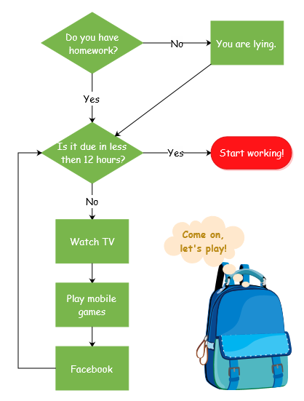

## A flowchart is a diagram constructed from connected shapes representing a process or a plan. Here is an example of a simple flowchart illustrating the process of withdrawing cash.

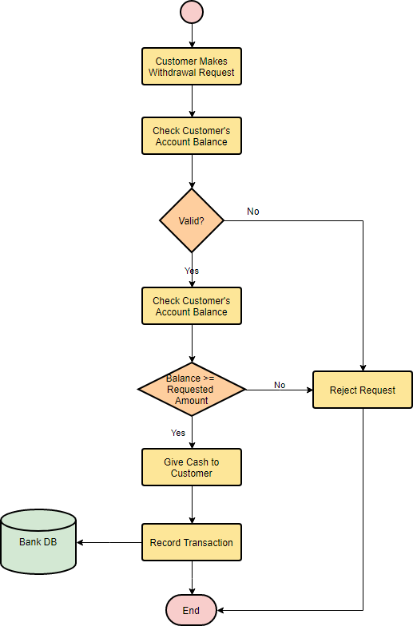

# Flowchart Symbols

## In a standard flowchart, different shapes have different conventional meanings. The meanings of some of the more common shapes are as follows:

## ***Terminator***

## The terminator symbol represents the starting or ending point of the system.

## IMG_256

## ***Process***

## A box indicates some particular operation.

## IMG_257

## ***Document***

## This represents a printout, such as a document or a report.

## IMG_258

## ***Decision***

## A diamond represents a decision or branching point. Lines coming out from the diamond indicates different possible situations, leading to different sub-processes.

## IMG_259

## ***Data***

## It represents information entering or leaving the system. An input might be an order from a customer. An output can be a product to be delivered.

## IMG_260

## ***On-Page Reference***

## This symbol would contain a letter inside. It indicates that the flow continues on a matching symbol containing the same letter somewhere else on the same page.

## IMG_261

## ***Off-Page Reference***

## This symbol would contain a letter inside. It indicates that the flow continues on a matching symbol containing the same letter somewhere else on a different page.

## IMG_262

## ***Delay or Bottleneck***

## Identifies a delay or a bottleneck.

## IMG_263

## ***Flow***

## Lines represent flow of the sequence and direction of a process.

## IMG_264

# When to Draw Flowchart Diagram?

## Using a flowchart has a variety of benefits:

## It helps to clarify complex processes.

## It identifies steps that do not add value to the internal or external customer, including: delays; needless storage and transportation; unnecessary work, duplication, and added expense; breakdowns in communication.

## It helps team members gain a shared understanding of the process and use this knowledge to collect data, identify problems, focus discussions, and identify resources.

## It serves as a basis for designing new processes.

# How to draw a Flowchart Diagram?

## How do you get from a complex task to an organized flowchart describing how to do it?

## Start with a flowchart containing just the task.

## Now break it down into smaller, more specific steps in another flowchart.

## Then, consider any possible exception in the flow, if so, add decision node for the alternative paths.

## Keep on repeating this process until you've reached steps that are simple enough for everyone to fully understand it.

# Flowchart Example – Hand Washing Example

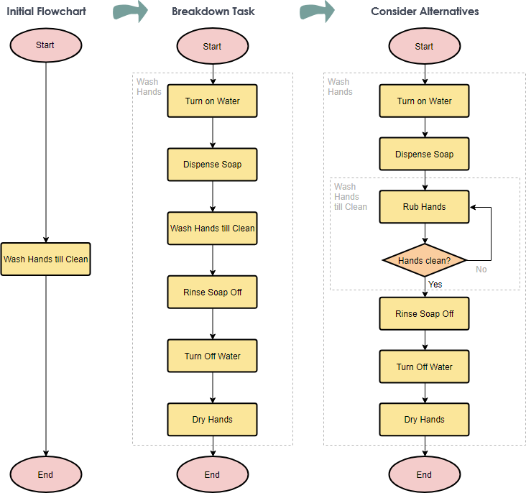

# Flowchart Example – Simple Algorithms

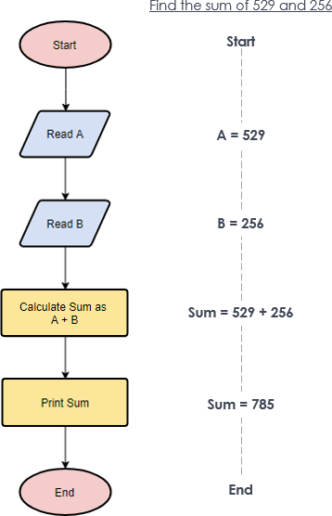

# Flowchart Example - Calculate Profit and Loss

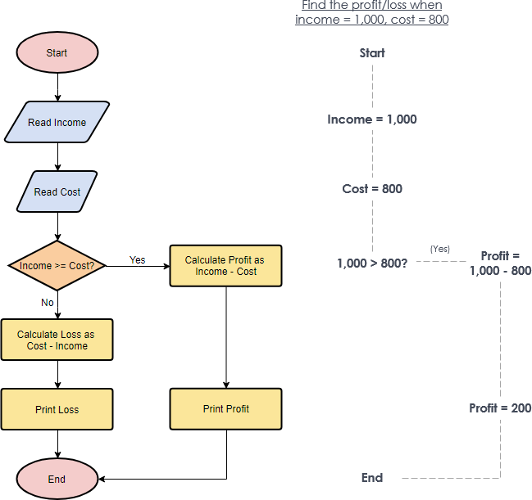

# Flowchart Example - Make a Toast

